AiTECCC website - Collaborative webpage (Bios and headshots)

Founding Members
 | Dr. Clare Ardern, PhD  Assistant Professor, Department of Physical Therapy, Faculty of Medicine, UBC  Clare is an Australian-trained physiotherapist and health researcher, appointed as Assistant Professor in the Department of Physical Therapy at UBC. She leads the DigiMSK research team, whose work brings researchers, patients, clinicians, designers and policy-makers together to re-imagine musculoskeletal health care services so that they deliver the right care in the right place at the right time. Clare has served the international musculoskeletal rehabilitation community as a journal editor for a decade. She is the current Editor-in-Chief for the Journal of Orthopaedic & Sports Physical Therapy (JOSPT), and JOSPT Open, and hosts the weekly JOSPT Insights podcast, which is downloaded over 35,000 times each month.
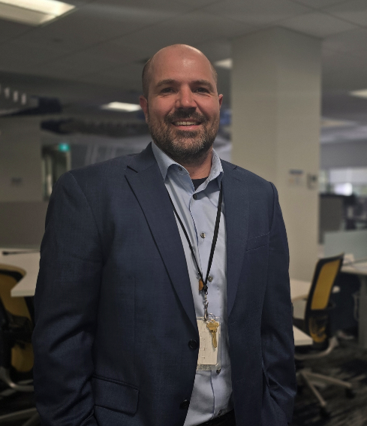 | Matthew Erickson RN BScN MBA  Acting Executive Director, BC Public Service  Matt Erickson is an emergency nurse by training who has expanded his expertise with a business degree and experience in health policy. His passion lies in tackling complex challenges in healthcare, particularly those related to access and flow within emergency departments.  Currently focused on improving emergency department sustainability in B.C., Matt brings a strategic and collaborative approach to solving systemic issues. His commitment to continuous learning has driven him to pursue further education and leadership development. Over the course of his career, he has built a strong foundation as a manager, director, and leader, gaining valuable skills that support his mission to improve patient care and system performance.
 | Dr. Corinne Hohl, BSc, MHSc, MDCM, FRCPC  Head, Department of Emergency Medicine, UBC  Corinne is the Head and a Professor in UBC’s Department of Emergency Medicine, a Scientist at the Centre for Clinical Epidemiology and Evaluation, and Associate Member of UBC’s School of Population and Public Health. She completed her MDCM and FRPC at McGill University and Masters training in Epidemiology at UBC. Corinne practices Emergency Medicine at Vancouver General Hospital and focuses her research on patient safety, health systems innovation, and innovative trials. In 2020, she became Chair of the Canadian COVID-19 Emergency Department Rapid Response Network, significantly contributing to the pandemic response. This network became the largest active research network in Emergency Medicine in Canada. In 2022, she received the Dr. Ian Stiell Researcher of the Year Award from the Canadian Association of Emergency Physicians.

Steering Committee
 | Dr. Helen Novak Lauscher  Associate Lead, Digital Emergency Medicine, Faculty of Medicine, UBC  Dr. Helen Novak Lauscher is Associate Lead of Digital Emergency Medicine at UBC, where she leads a team working on research and evaluation in digital health, virtual care, and patient and public engagement in health contexts from acute to community. With a doctorate in educational psychology, her areas of specialty include participatory approaches to research and evaluation, qualitative methods, and understanding collaboration and relationships in virtual/hybrid settings.
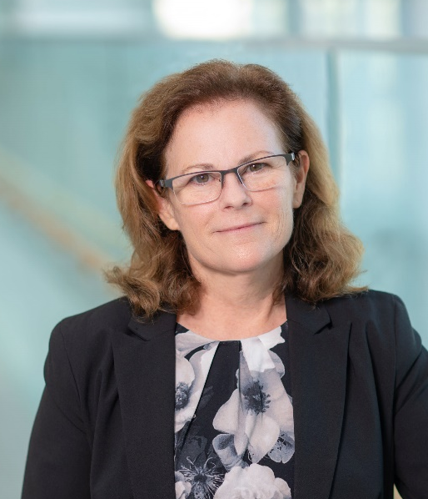 | Christie A. Newton, MD, CCFP, FCFP  Associate Vice-President, Health Associate Professor, Department of Family Practice, Faculty of Medicine, UBC  Christie has been very engaged with UBC Health activities for many years. She is a co-facilitator of the TBC@UBC Network and a member of the Health Systems Partnership Group. She has also been working closely with UBC Health on the design and implementation of a new interprofessional teaching clinic for the Gateway Building on UBC Vancouver campus aimed at modelling innovative team-based care and collaborative health education.  In addition to her appointment at UBC Health, Christie served as the President of the College of Family Physicians of Canada 2022-2023 and is currently a Board Director of the Health Data Coalition.

Member
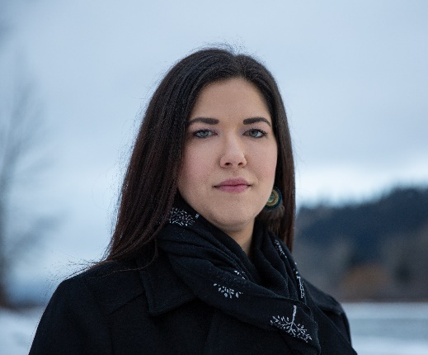 | Dr. Terri Aldred  Medical Director, Primary Care for BC’s First Nations Health Authority  Dr. Terri Aldred is Dakelh (Carrier) from the Tl’Azt’En Nation, located north of Fort St. James, British Columbia. She is a member of the Lysiloo (Frog) Clan, traditionally known as the voice of the people, and proudly follows her mother’s and great-grandmother’s line, Cecilia Pierre (Prince). Dr. Aldred was raised between the inner city of Prince George and the Tachet reserve in Lake Babine Territory—experiences that inspired her commitment to serve and advocate for Indigenous communities through medicine.
 | Dr. Craig Mitton  Professor, School of Population and Public Health, UBC  Dr. Mitton’s research is focused on the application of health economics to impact health policy and to inform clinical practice. He has worked extensively with health authorities in numerous countries on the development and implementation of priority setting and resource allocation processes.  He is the lead author on a book titled “The Priority Setting Toolkit: a guide to the use of economics in health care priority setting” and is the lead or co-author on more than 170 peer reviewed journal articles. In addition, he has delivered over 200 presentations across many different countries and regularly runs workshops and short courses on health economics and health care priority setting.

